**UJIAN AKHIR SEMESTER**

**MOBILE PROGAMMING**



**Oleh :**

|  |  |
| --- | --- |
| **Nama** | **: Rista Septiana Rakhmawati** |
| **Kelas** | **: JI183** |
| **NIM** | **: 180030841** |

**SISTEM INFORMASI**

**INSTITUT TEKNOLOGI DAN BISNIS**

**STIKOM BALI JIMBARAN**

**JUNI 2020**

* Hasil Screenshoot Scroll View :

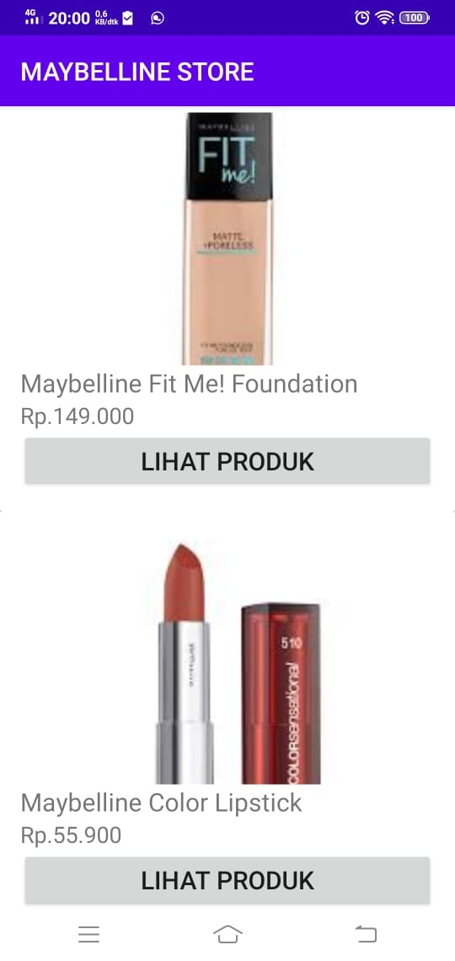 

* Screenshoot Hasil Tap Button

